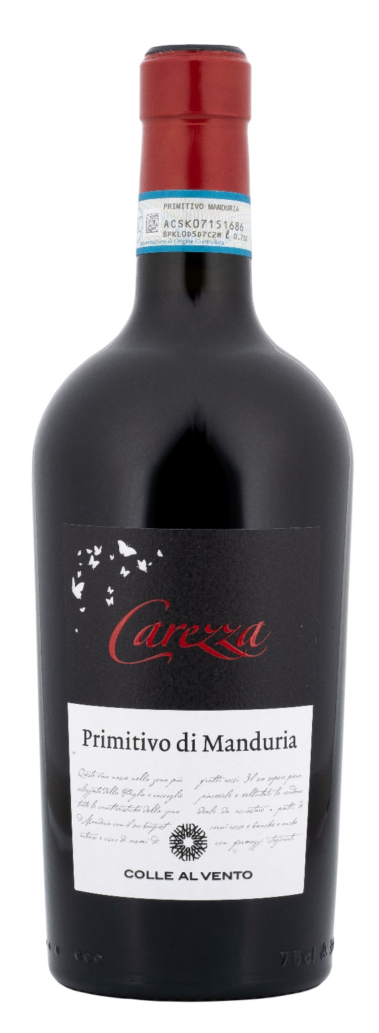
PRIMITIVO DI MANDURIA DOP – CAREZZA

Grape: Primitivo 100%
Alc. Vol.%: 15
Vintage: 2024
Residual sugar g/l: 11,0
Total acidity g/l: 6,6
Region: Apulia
Production zone: Vineyards in the area of Manduria and Sava (Taranto)
Capacity: 750ml

CHARACTERISTICS

Vinification: In steel tanks and oak vats
Aging: At least 8 months in steel/oak
Yield per ha: 9000kg
Colour: Intensive red with purple reflections
Bouquet: Intense, aromas of red fruits like raspberry and cherry and a subtle note of vanilla
Flavour: Full-bodied, velvety, warm, with a smooth and long lasting ending

SERVING SUGGESTIONS

Excellent with red meat, especially lamb and venison and ripe cheese.
Serving temperature 18 °C
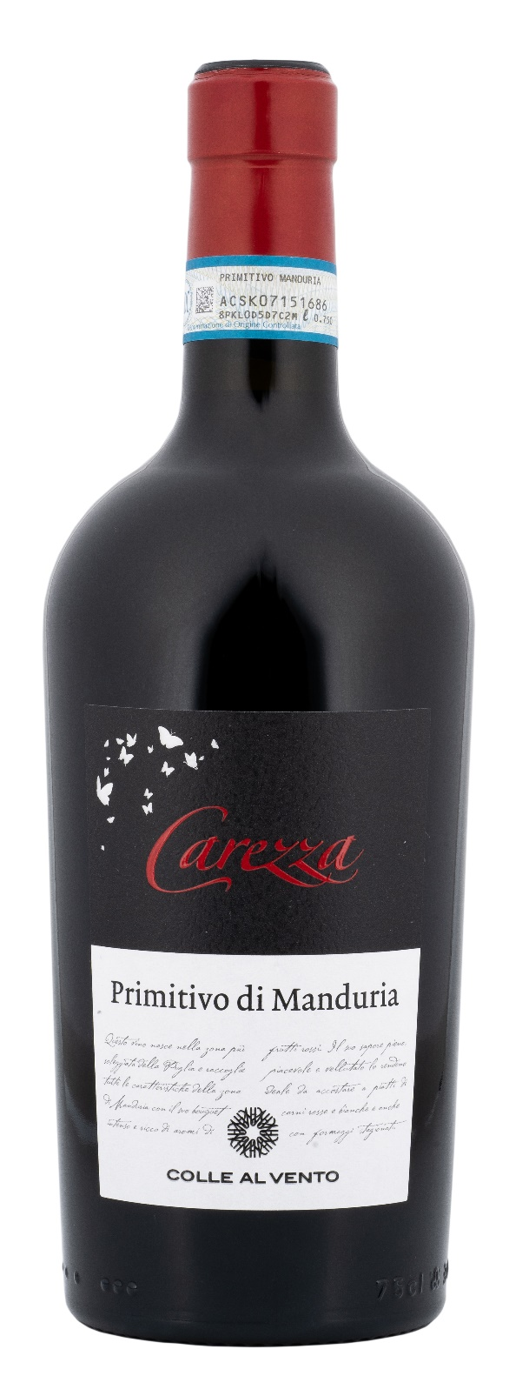
TECHNICAL INFORMATION / PALLETIZING

Size 750ml:
Article Nr. V03005A
GTIN-13 bottle 8017868003441
GTIN-13 carton 8017868003458
Closure Cork
Bottles / carton 6 bottles
Pallet size 80x120cm
Cartons/layer 17
Cartons/pallet 102
Kg/carton 8,4
Kg/pallet 884

Contains sulphites
GMO Free
Revisione 01. 13.05.2026

